**Practical No. 8**

**Aim:** To implement 4­bit magnitude comparator.

**Apparatus:** 4 bit magnitude comparator IC (74LS85), Connecting wires, Bread Board, Power supply, LED, DMM.

**Theory:**

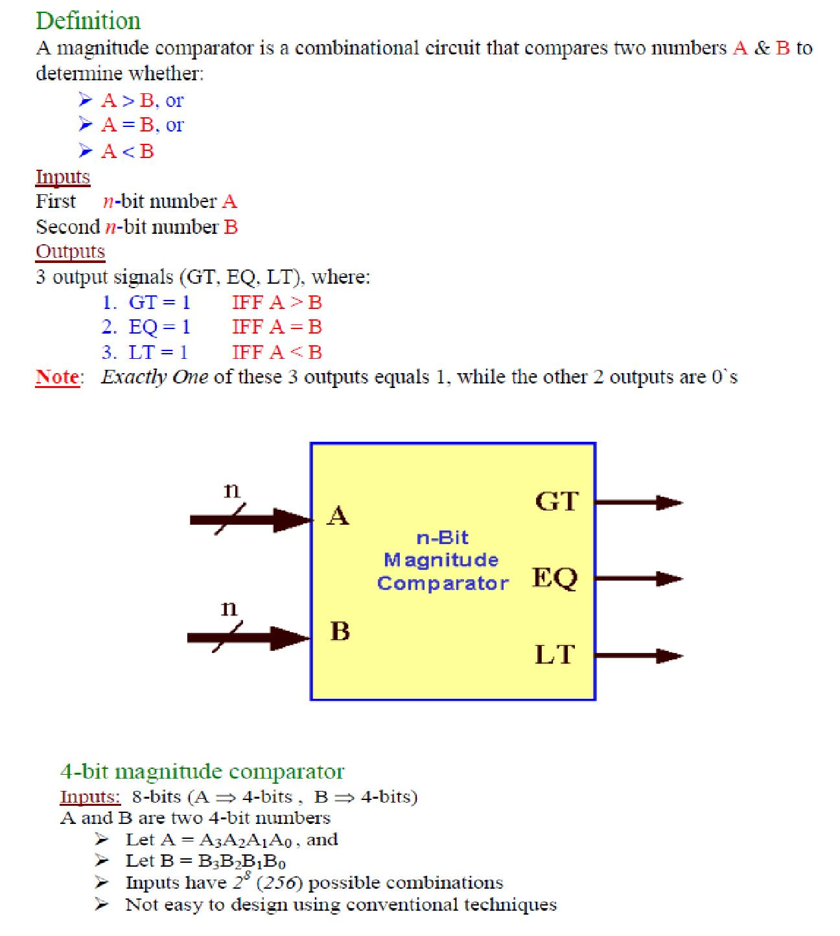

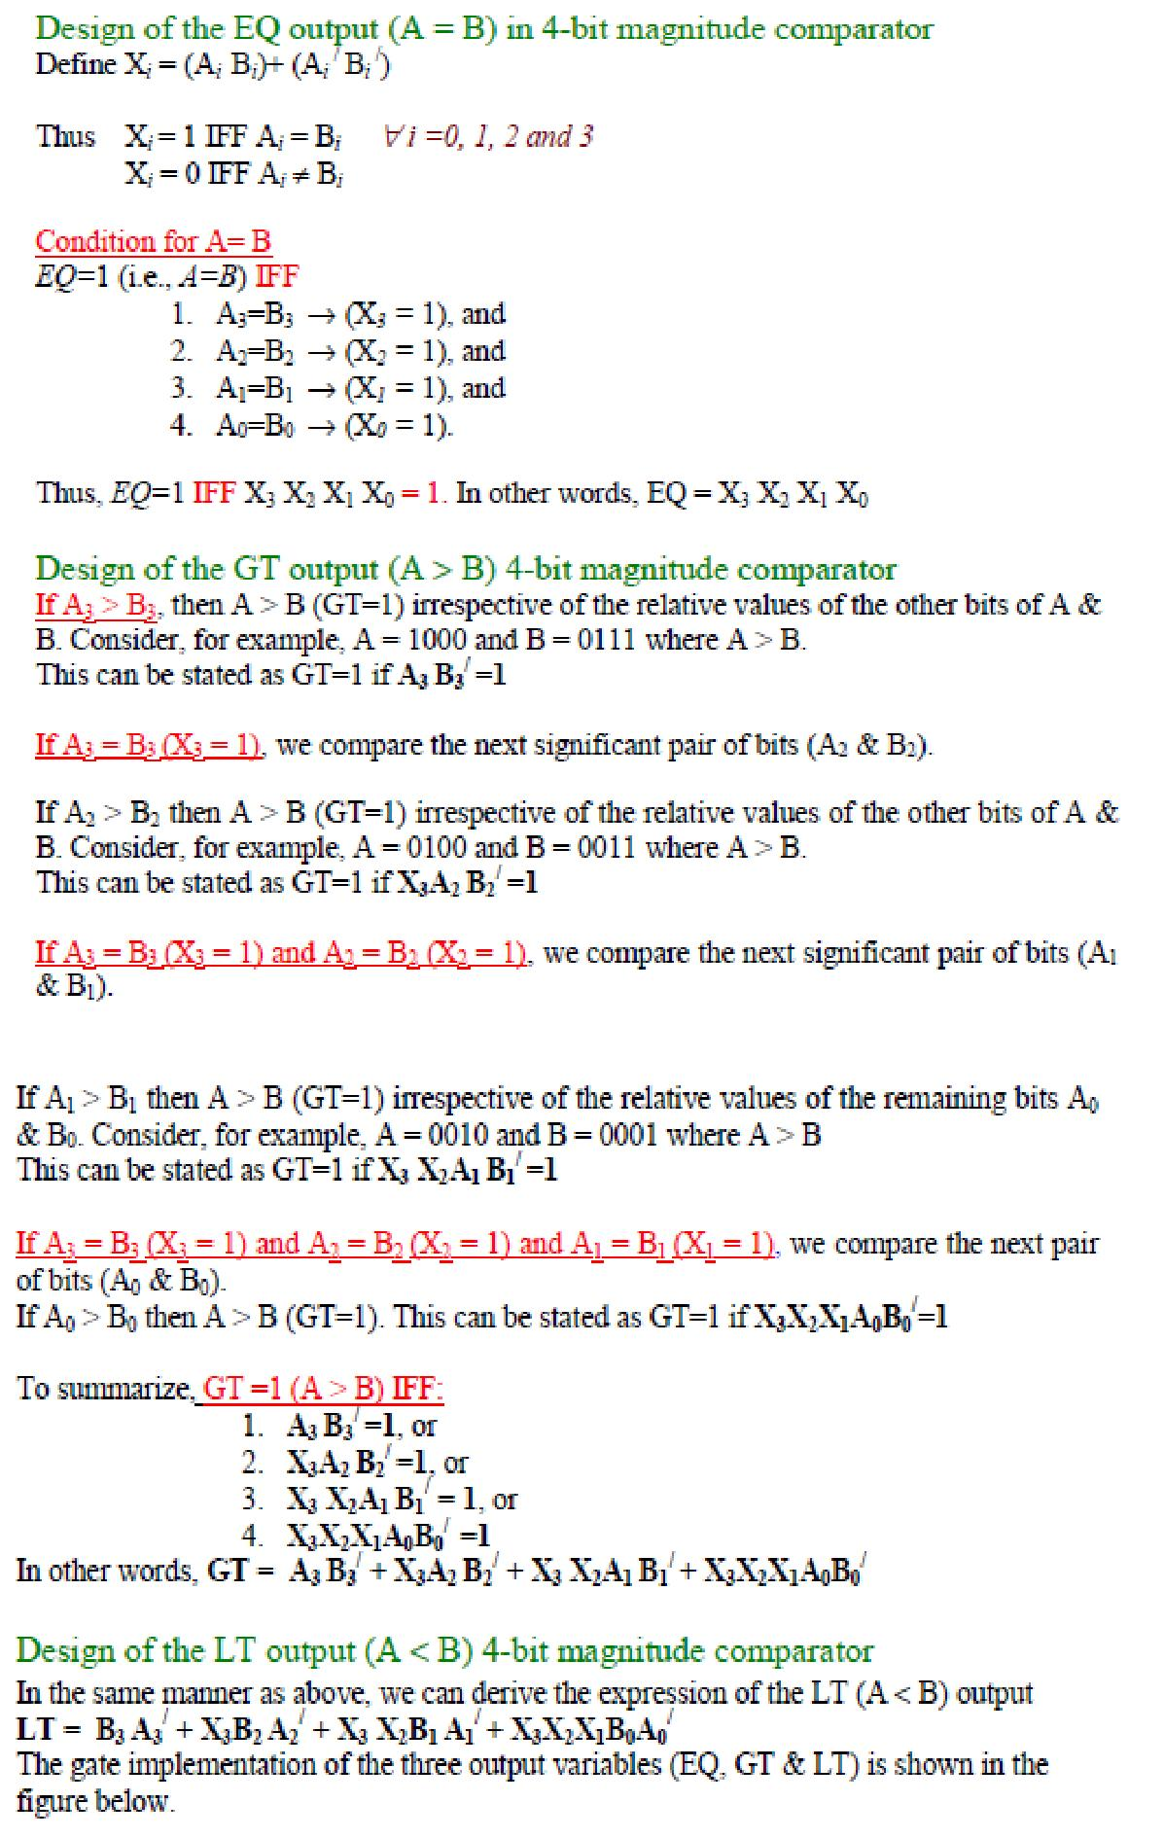

**Logic Diagram:**

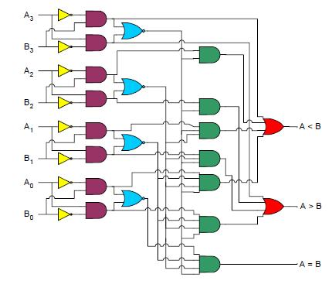

**Procedure:**

1. Do the connection as per below pin diagram for various input data or 4 bit number.
2. Apply proper input condition and observe the output information of led on/off.
3. Compare theoretical data with observation and write conclusion.

**Pin Diagram:**

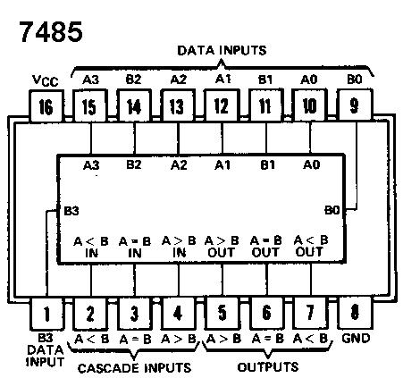

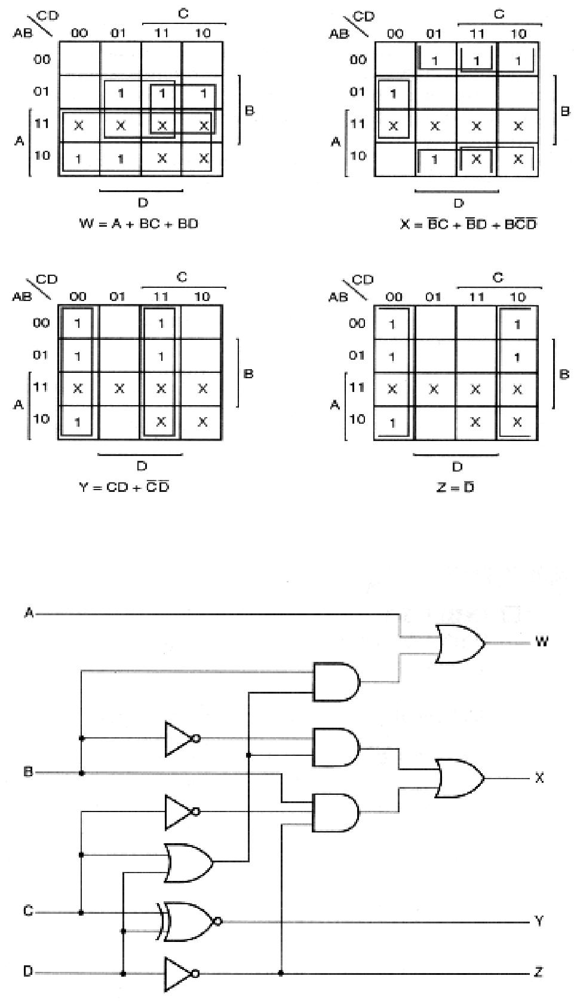

**BCD to Excess­3 Code conversion logic diagram**

**Procedure:**

1. Do the connection as per Combinational logic diagram for various input data.
2. Apply proper input condition and observe the output information of using DMM.

Compare theoretical data with observation and write conclusion

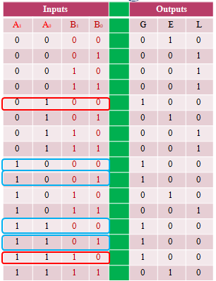

**CIRCUIT DIAGRAMS:**

**2- Bit Magnitude comparator**

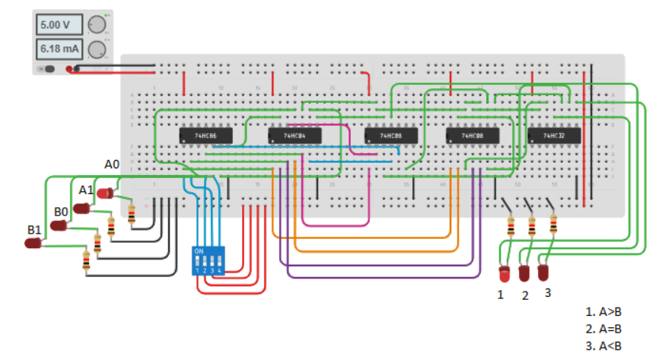

**CONCLUSION:**

 Comparators compares an input signal with a reference voltage and has as a result a logic stage, which indicates whether the signal is lower or higher.